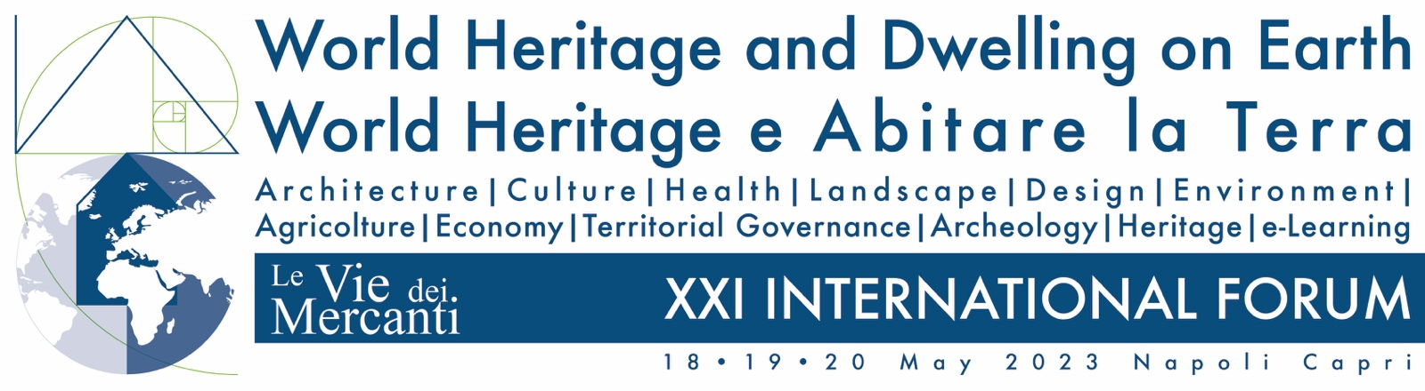

This form includes all the formats required. Please, use it as a model or template.

The first sheet must contain information about all authors:

Name SURNAME
Position
Affiliation
City, State
Mail address
Other contacts (not mandatory)

Specify your preference, either for oral or not oral presentation.

Paper title

The second sheet must contain the title and the abstract without any reference to the authors or affiliation. The text should be minimum 800 characters spaces included, maximum 1500 characters spaces included.
Language: English
- Title of the paper: left aligned, bold, maximum 2 lines.
- Text of the abstract: justified.
- Leave one blank line between title of the paper and text of the abstract.
Send your abstract as attached file in Word for Windows within 27 February 2023, to: leviedeimercanti@benecon.it You will receive a confirmation mail.

One image can be sent in tif format, grayscale, maximum dimension 12 cm. to be published in the abstracts printed book.

Based on blind peer reviews, abstracts may be accepted, conditionally accepted, or rejected. Authors of accepted and conditionally accepted papers will be invited to submit full papers.
All the accepted articles will be published in the Conference CD ROM proceedings with an ISBN number.
Abstracts will be published in a printed book. Participants will receive the proceedings book and CD ROM at the conference.
By submitting your paper, you are hereby authorizing the Conference organizers to publish your abstract and full paper in the Conference proceedings.

